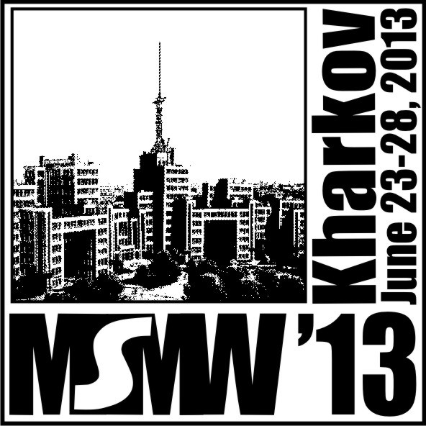 | THE EIGHth International Kharkov Symposium ON PHYSICS AND ENGINEERING OF MICROWAVES, MILLIMETER AND SUBMILLIMETER WAVES (MSMW’13) AND WORKSHOP ON TERAHERTZ TECHNOLOGY (TERATECH’13)  Kharkiv, Ukraine, June 23-28, 2013
 | 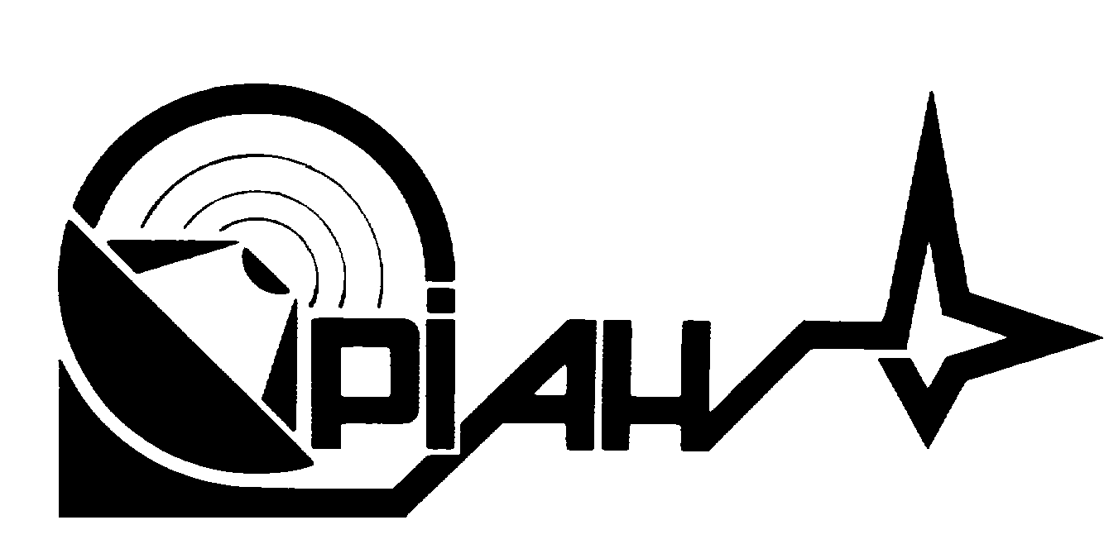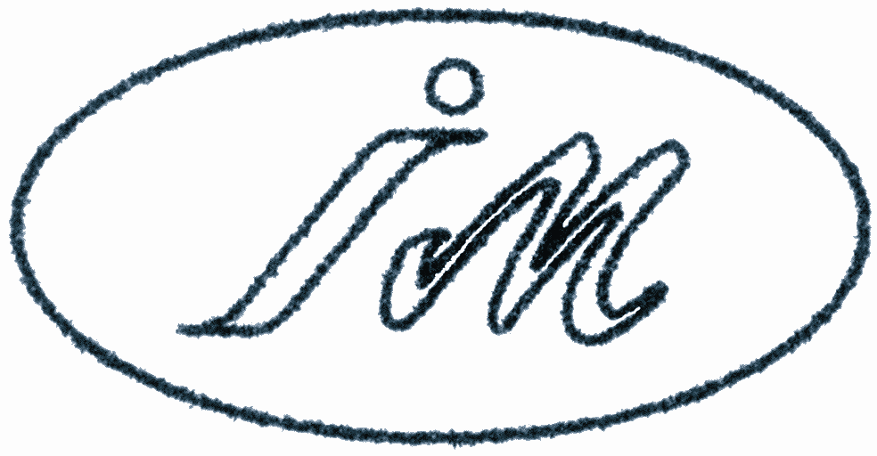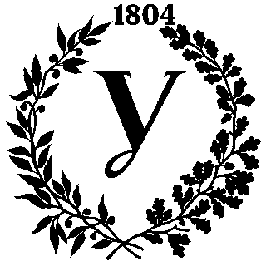

Announcement • MSMW’13 & TERATECH’13 • Call for PAPERS
Organized by:
- The Scientific Council of the National Academy of Sciences of Ukraine on Radio Physics and Microwave Electronics
in collaboration with IRE NASU, IRA NASU, IMag NASU and MESU, KhNU, KhNURE
with the support of the following organizations:
- IEEE AP/MTT/ED/AES/GRS/NPS/EMB Societies East Ukraine Joint Chapter,
- IEEE MTT/ED/AP/CPMT/SSC Societies West Ukraine Joint Chapter,
- IEEE MTT/ED/COM/CPMT/SSC Societies, Central Ukraine Joint Chapter,
- Ukrainian National URSI Committee.

The support of the IEEE AP, MTT, ED, NPS, and AES Societies and the URSI is under negotiation

Introduction: The Eighth International Kharkov Symposium on Physics and Engineering of Microwaves, Millimeter and Submillimeter Waves (MSMW'13) will be held in Kharkov, Ukraine on June 23-28, 2013. Within the symposium, the Workshop on Terahertz Technology (TeraTech'13) will be organized. During the symposium, a one-day workshop “Complex conductivity and wave symmetry of Fe-based superconductors” is also planned. These events will be sponsored by the National Academy of Sciences of Ukraine (NASU) Scientific Council on Radio-Physics and Microwave Electronics and A. Usikov Institute for Radiophysics and Electronics of NASU. IRE NASU has always been one of the major Ukrainian research organizations in this field. It was established in 1955 with the main tasks of developing the mm-wave vacuum sources, wave propagation and radars, and hot-plasma diagnostic systems for Tokamak controlled fusion machines; later it was involved in the development of in-orbit remote sensing and communication systems. Main collaborating organizations are the Institute of Radio Astronomy (IRA) of NASU, which branched off IRE in 1985 and leads research in the mm-wave radars and radio astronomy, Institute of Magnetism (IMag) of NASU and Ministry of Education and Science of Ukraine (MESU), which was founded in 1995 and performs research into modern problems of the physics of magnetism and magnetic materials, V. Karazin Kharkov National University (KhNU), the third oldest (since 1804) and highly reputed university in natural sciences in the Former Soviet Union (FSU), Kharkov National University of Radio Electronics (KhNURE), a technical university in Ukraine entirely in electronics and computers, three Ukrainian IEEE Joint Chapters, and the Ukrainian National URSI Committee. MSMW symposia were held several times in Kharkov since 1978 as regular FSU meetings on mm and submm waves and applications. It became a major event in this area and since 1991 it has been known as the International Kharkov Symposium - MSMW.
Transportation Connections: Every day Kharkov is accessible by direct flights of the Austrian Airlines from Vienna and Pegasus Airlines from Istanbul. International air connections are available to Kiev with numerous daily flights. This is to be followed by one-hour flight or an overnight train to Kharkov, 450 km to the East. It is also possible to reach Kharkov via Moscow, but in this case a Russian double-transit visa should be obtained. Every possible assistance will be provided as long as any problems may arise.

Visa: No visa is required for the citizens of the EU, Israel, Norway, Switzerland, Turkey, the USA, Canada, and Japan. The participants from the other countries need a valid visa to enter Ukraine. Organizing Committee will send official invitation letters to the authors of all accepted papers.
Young Scientist Travel Grants: travel grants might be expected to help young scientists from FSU and developing countries to attend the MSMW’13 & TERATECH’13. The number and amount of grants will depend on the success of the on-going search for sponsors.
Suggested Sessions:
W. Workshop on Terahertz Technologies  I. Electromagnetic theory and numerical simulation  II. Waves in semiconductors and solid state structures  III. Microwave superconductivity  IV. Wave propagation, radar, remote sensing and signal processing  V. Vacuum electronics | VI. Solid state devices  VII. Antennas, waveguide and integrated circuits  VIII. Radio astronomy and Earth’s environment study  IX. Radiospectroscopy, complex media, nanophysics  X. Scientific, industrial and biomedical applications  XI. R-functions, atomic functions, wavelets, fractals

MSMW’13 Chairman: Prof. Vladimir M. Yakovenko (IRE NASU)
MSMW’13 Co-Chairmen: Prof. Leonid M. Lytvynenko (IRA NASU)
Prof. Ilya I. Zalyubovsky (KhNU)
Prof. Michail F. Bondarenko, (KhNURE)
MSMW’13 Co-Organizers: Dr. Alexei A. Kostenko (IRE NASU) and Prof. Alexander I. Nosich (IRE NASU),
TERATECH’13 Co-Chairmen: Prof. Anatolii N. Pogorily (IMag of NASU and MESU) and Prof. Sergey I. Tarapov (IRE NASU)
MSMW’13 Local Organizing Chair: Dr. Alexei N. Kuleshov (IRE NASU)
Address: MSMW’13, IRE NASU, 12, Ak. Proskury St., Kharkiv, 61085, Ukraine
Phone/Fax: +380 -57- 315- 2105, E-mail: msmw13@ire.kharkov.ua, http://www.ire.kharkov.ua/MSMW13/index.htm
Deadlines: 3-page camera-ready papers by March 30, 2013
Instructions will be placed at the MSMW’13 Website

